JAVA 8 BASIC CODING :
- Link :
https://blog.devgenius.io/java-8-coding-and-programming-interview-questions-and-answers-62512c44f062
-----------------------------------------------------------------------------------------------------------------
Given a list of integers, find out all the even numbers that exist in the list using Stream functions?
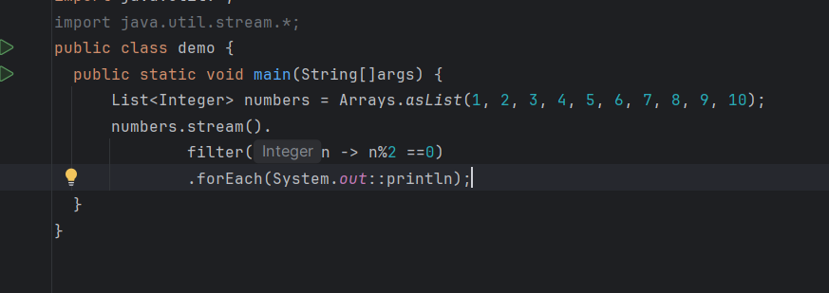
- Given a list of integers, find out all the numbers starting with 1 using Stream functions?
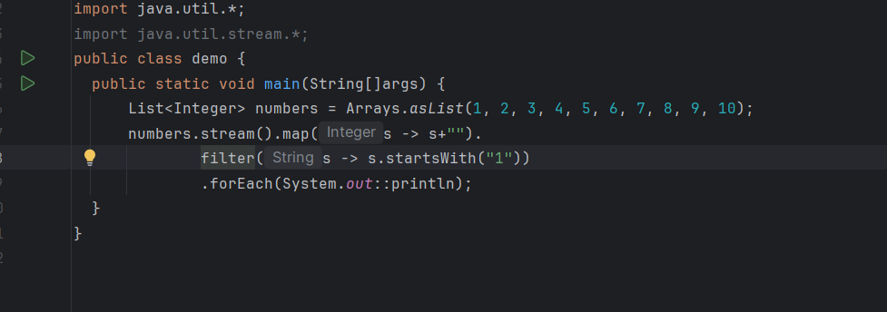
3. How to find duplicate elements in a given integers list in java using Stream functions?
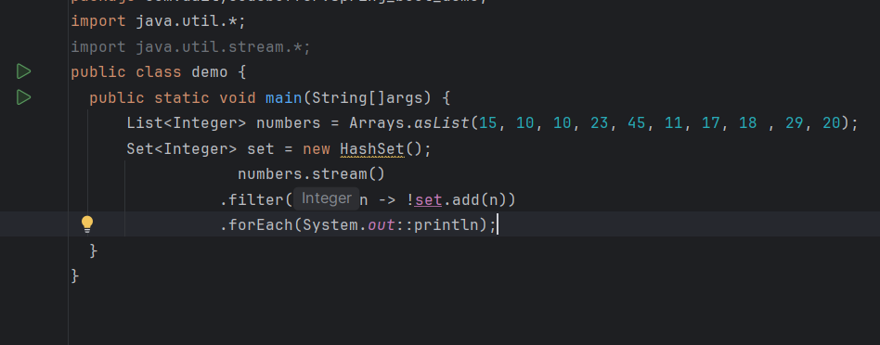
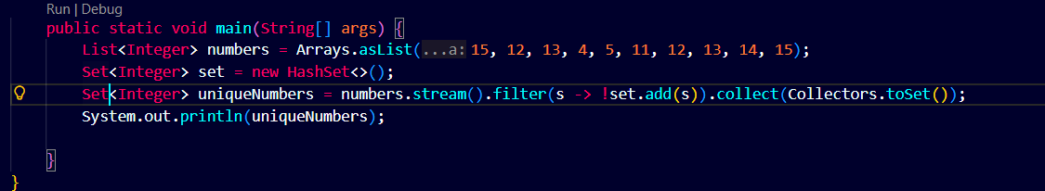
4. Given the list of integers, find the first element of the list using Stream functions?
**/ 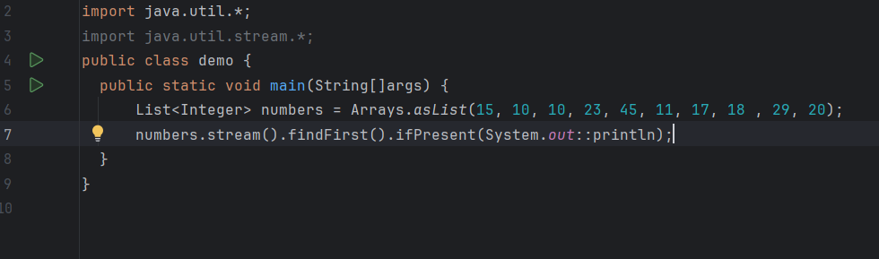
5. Given a list of integers, find the total number of elements present in the list using Stream functions?
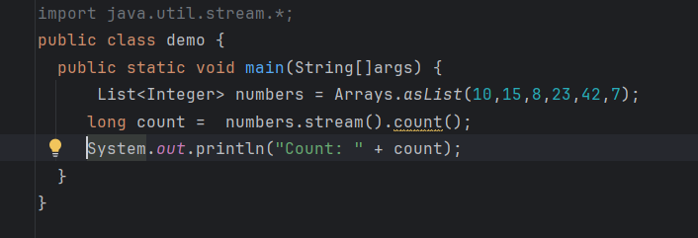
6. Given a list of integers, find the maximum value element present in it using Stream functions?
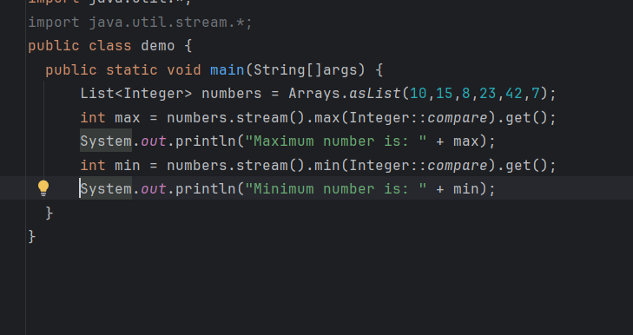
7 . Given a String, find the first non-repeated character in it using Stream functions?
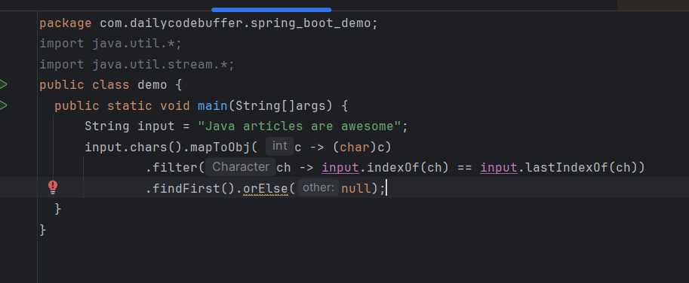
8. Given a String, find the first repeated character in it using Stream functions?
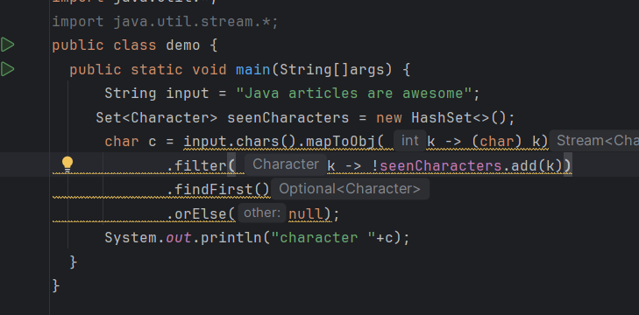
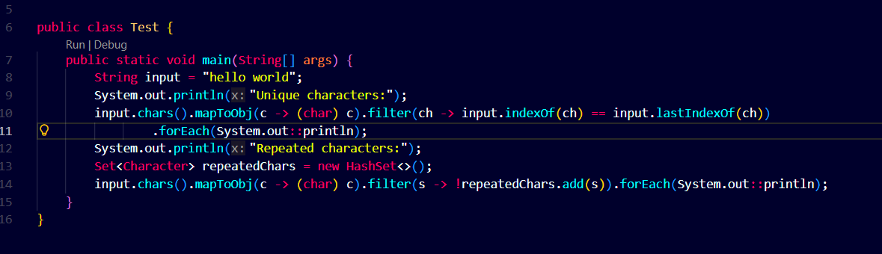
. Given a list of integers, sort all the values present in it using Stream functions?
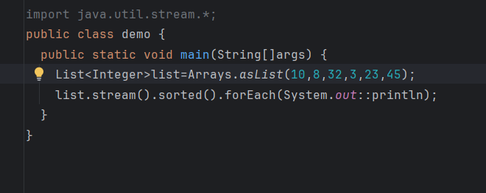
Reverse order ::
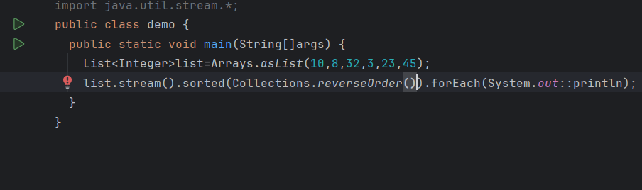
Given an integer array nums, return true if any value appears at least twice in the array, and return false if every element is distinct.
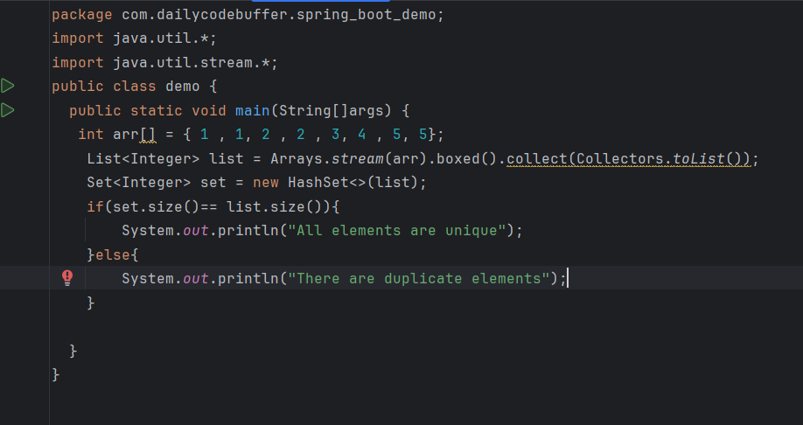
[13] Write a Java 8 program to concatenate two Streams?
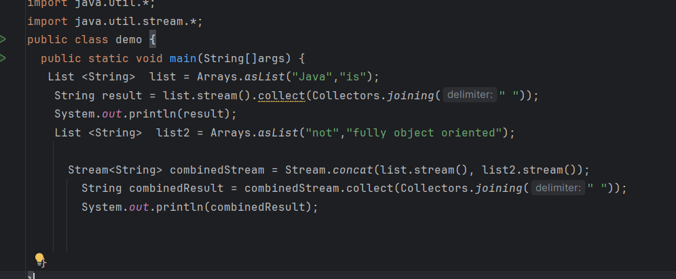
Java 8 program to perform cube on list elements and filter numbers greater than 50.
-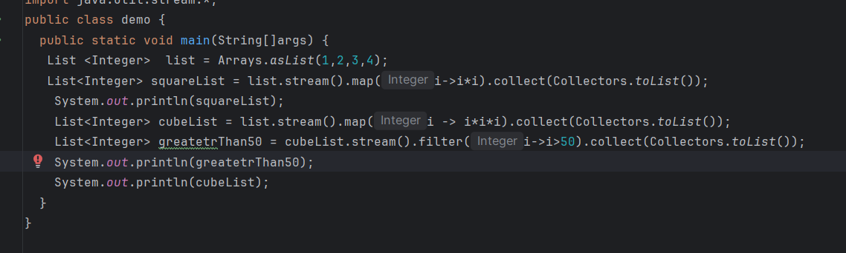
How to use map to convert object into Uppercase in Java 8?
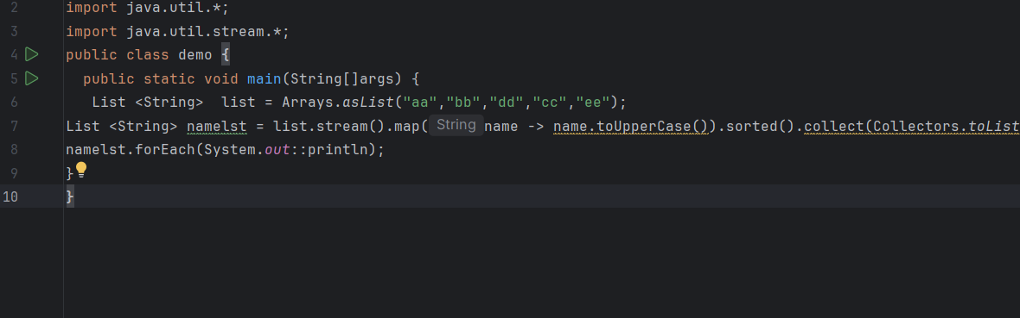
. How to convert a List of objects into a Map by considering duplicated keys and store them in sorted order?
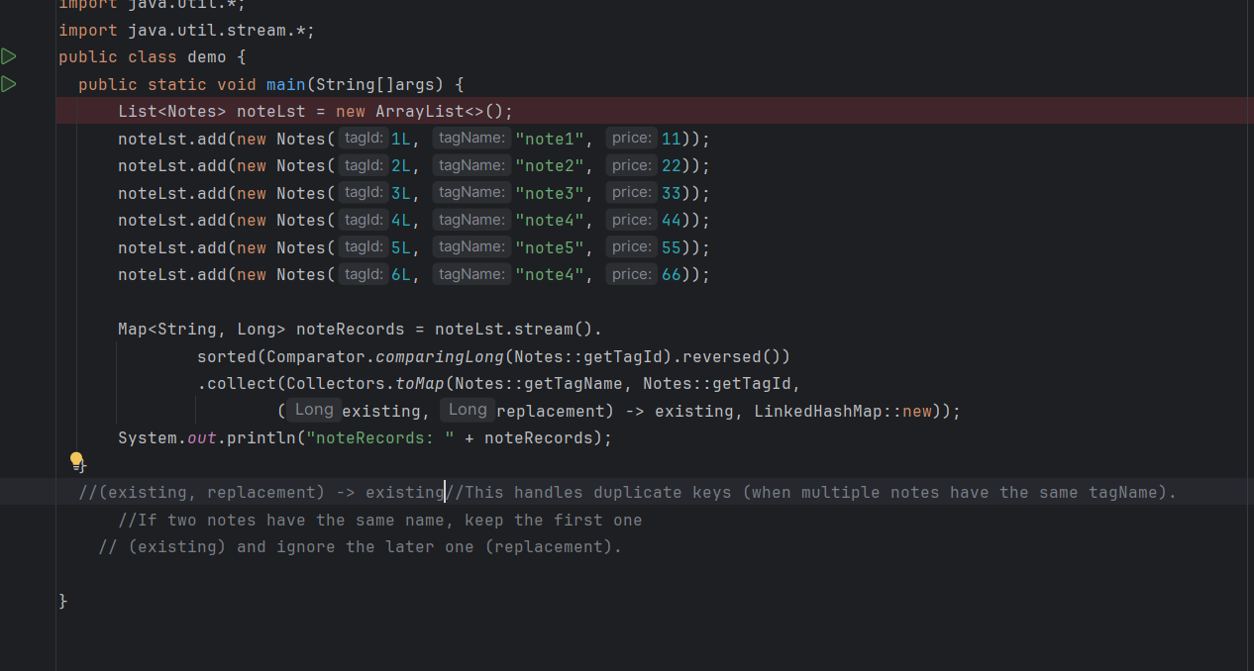
How to count each element/word from the String ArrayList in Java8?
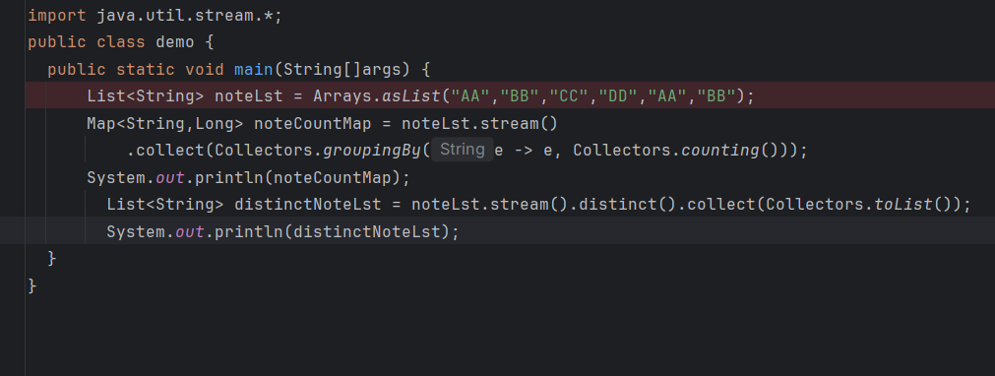
How to find only duplicate elements with its count from the String ArrayList in Java8?
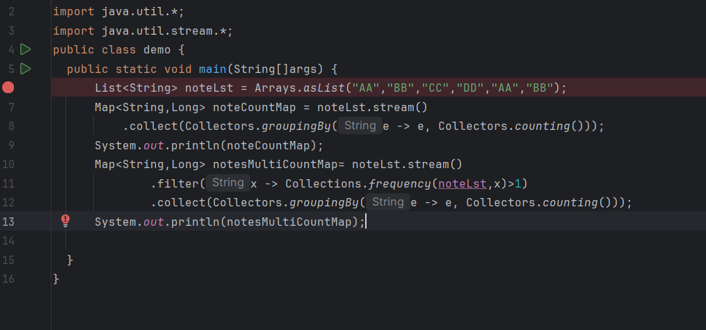
Write a Program to find the Maximum element in an array?
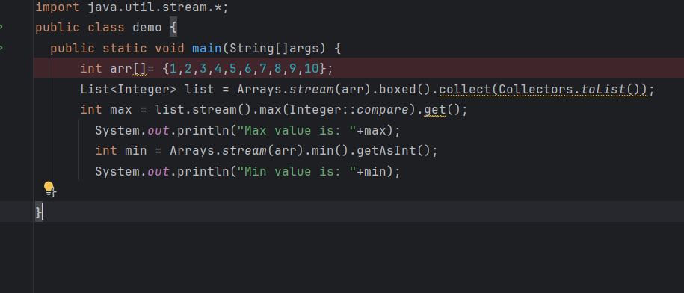
In the above image we can use arrays.stream or convert it into list also .
-----------------------------------------------------------------------------------------------------------------
Frequency of each character in string
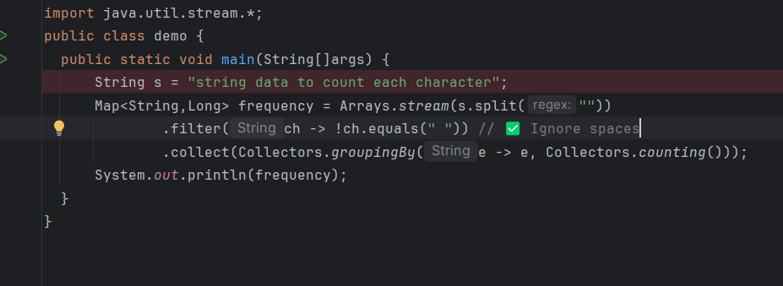
Sort the note List Based on Name if name is same then price
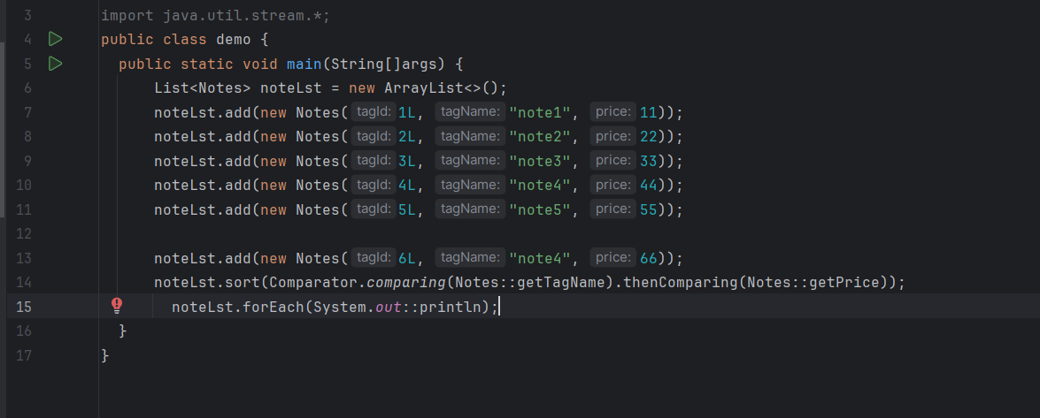
Missing Numbers in List :
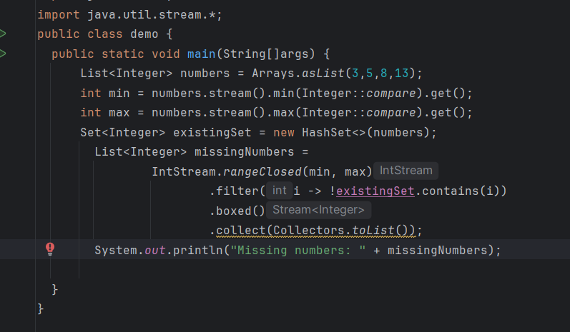
Sort the Map values based on Key and value
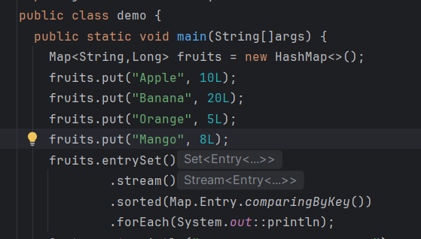
Comparing By Value
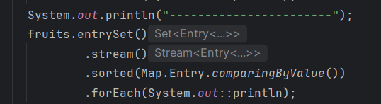
To Preserve Order we store values in Map ::
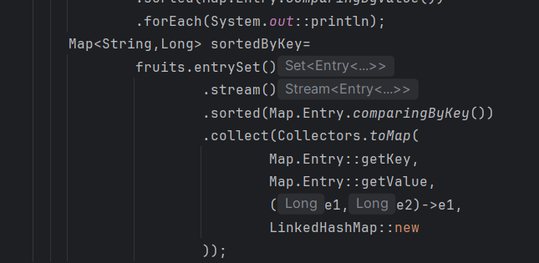
Here we use Map.entrySet() we used because
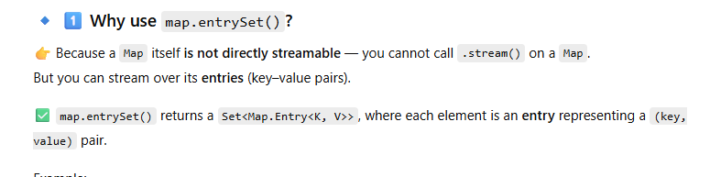
Then we use Collectors.toMap structure
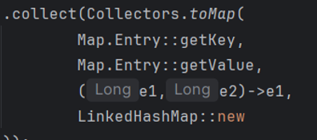
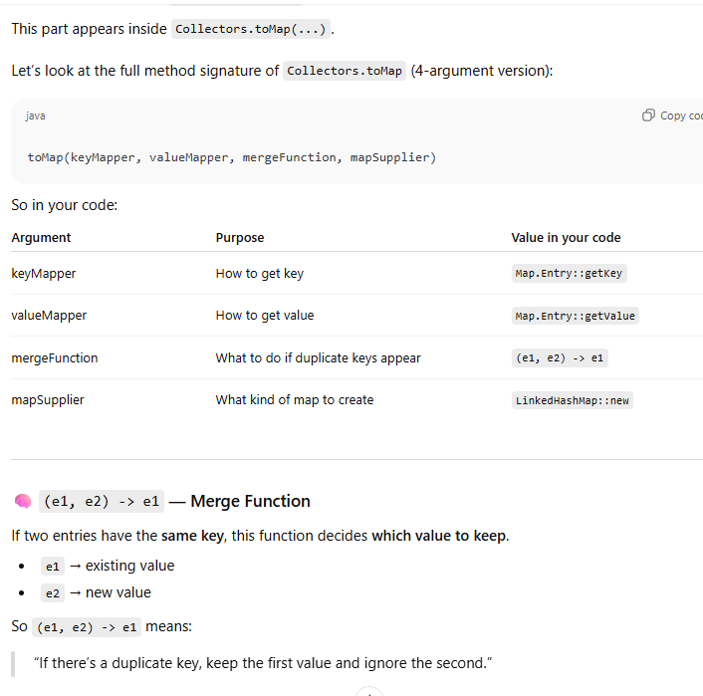
Write a program to filter out string into unique and duplicate list ?
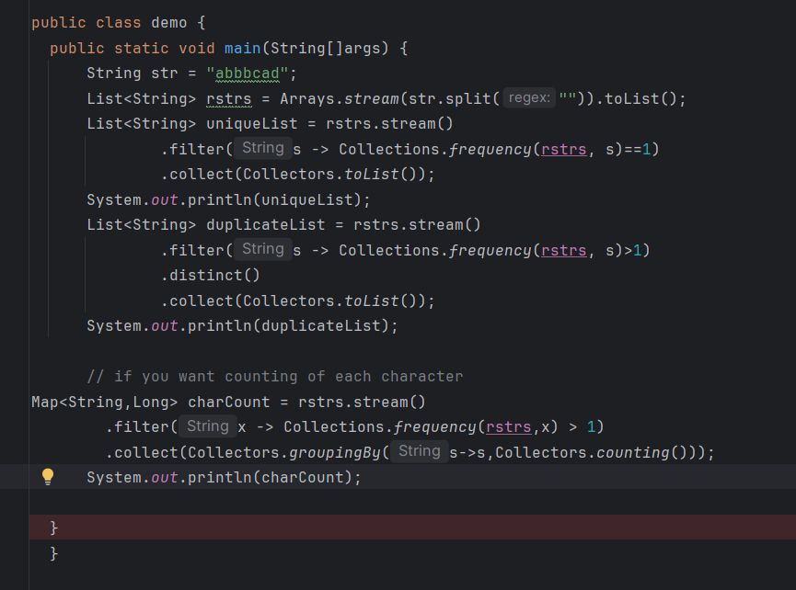
Write a program to filter list of employees whose annual price is greater than 5000
provide increment to 1.10 .
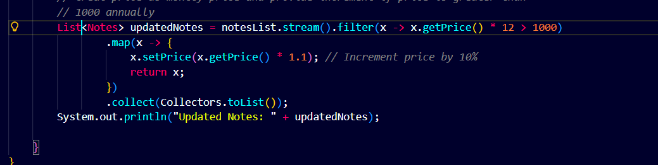
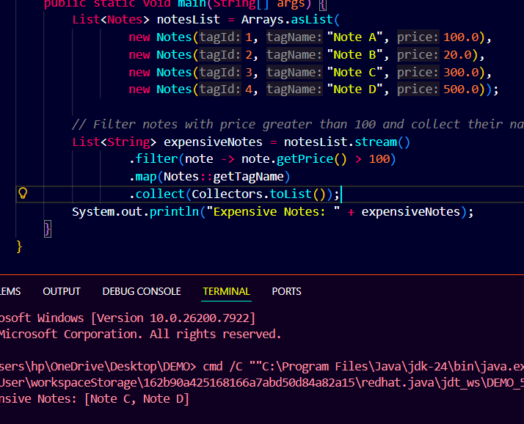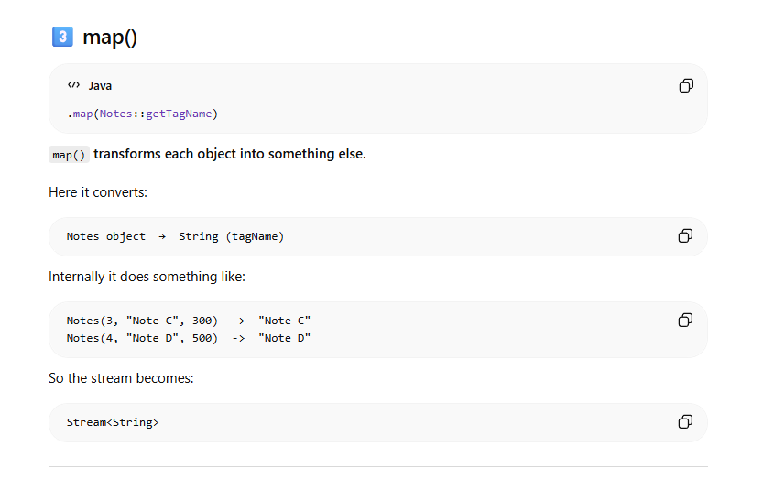

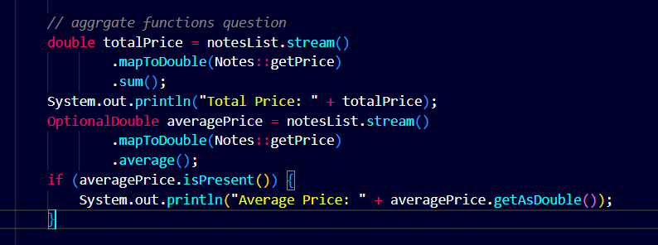
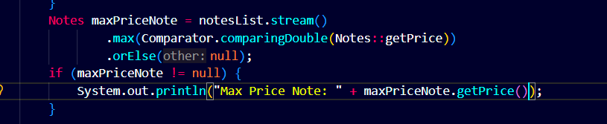
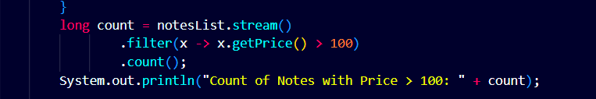
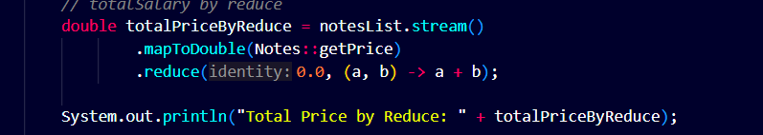
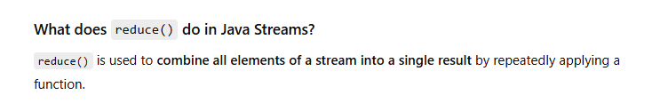
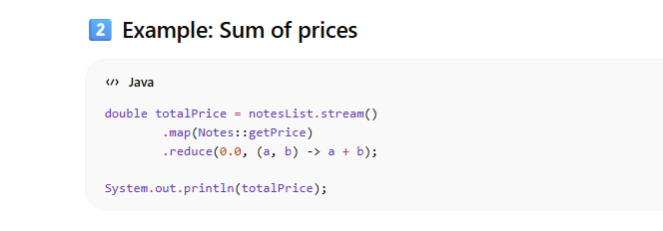
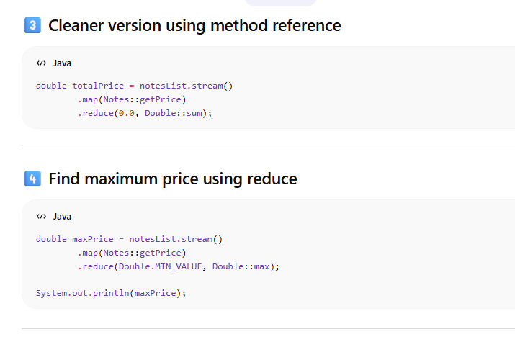
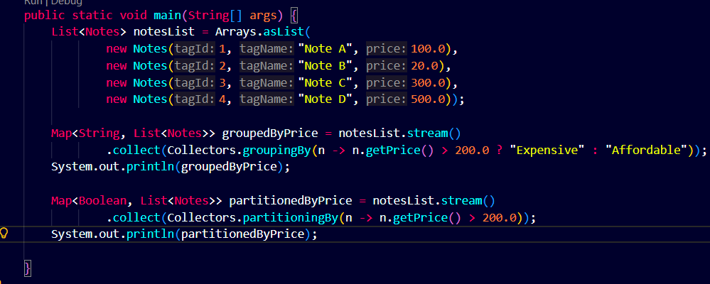
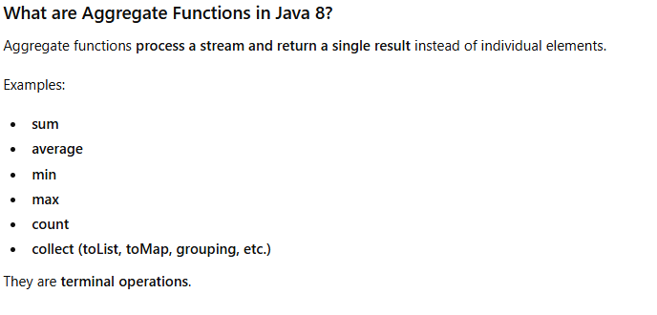
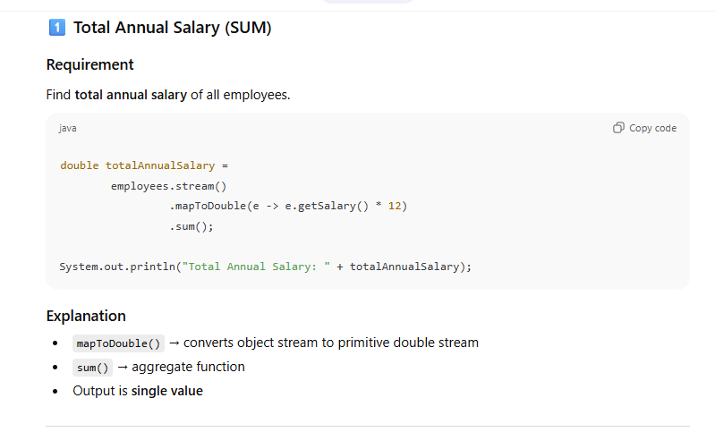
[2]
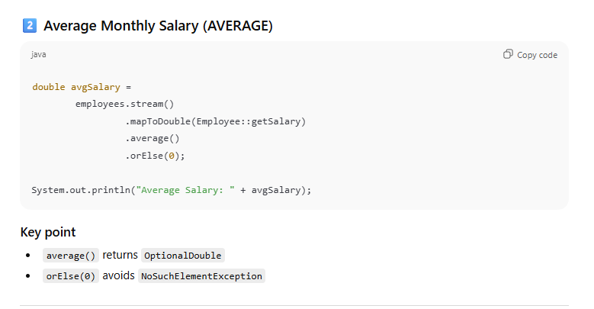
[3]
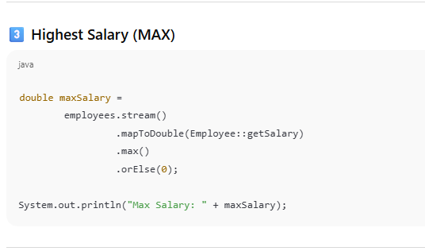
[4]
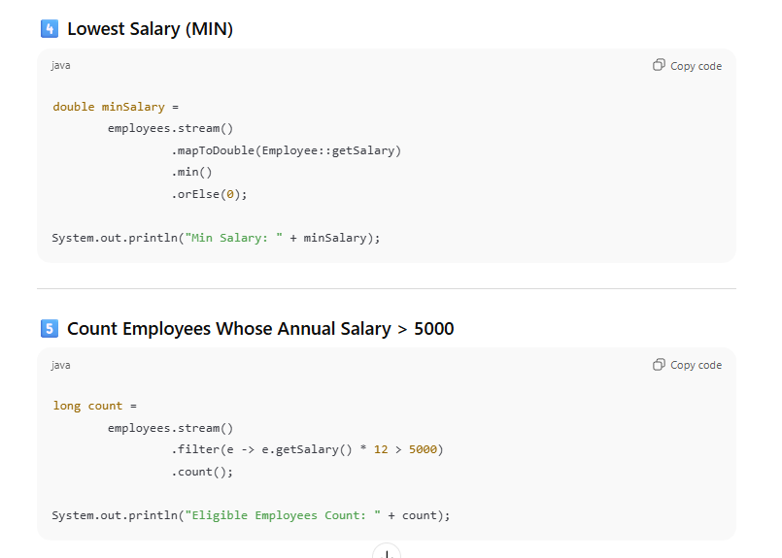
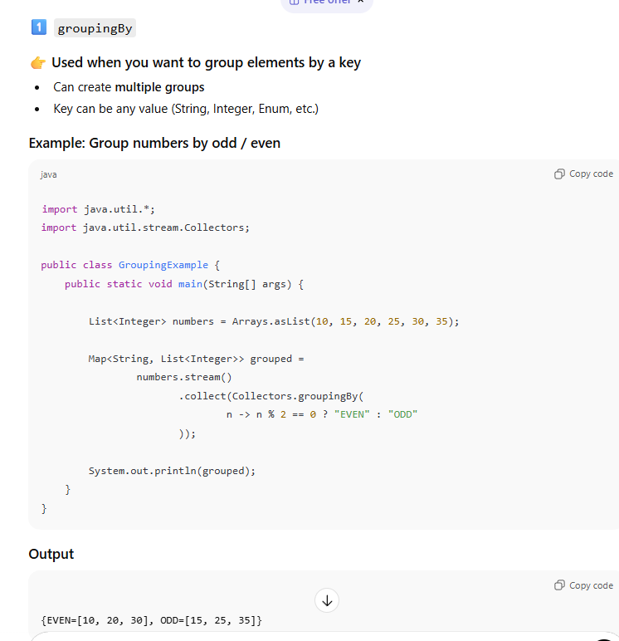
[2]
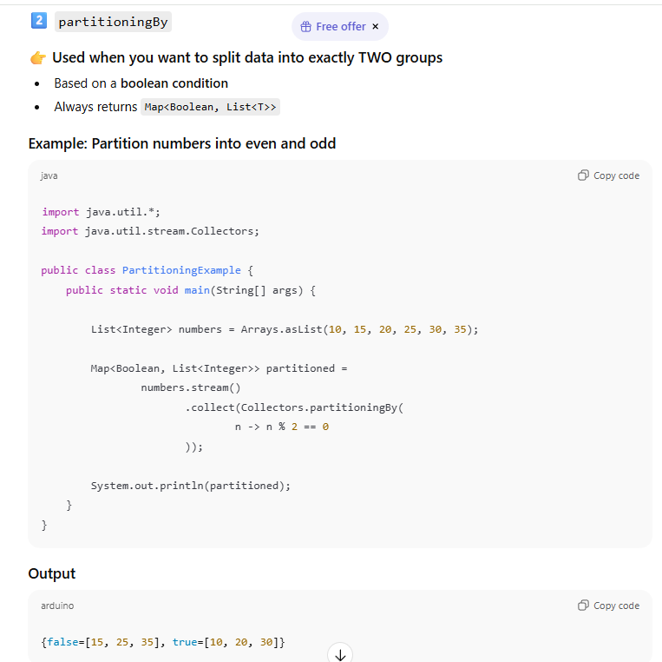
Second Highest Salary employee Name :
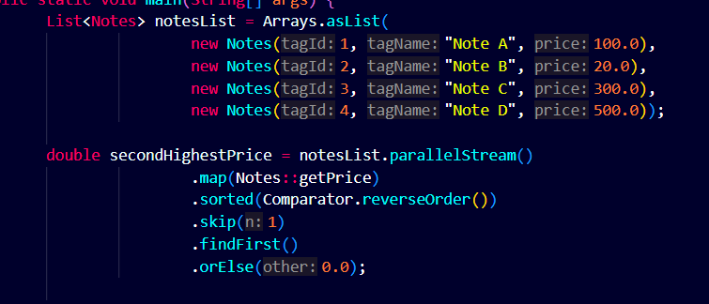
Not a correct approach ::
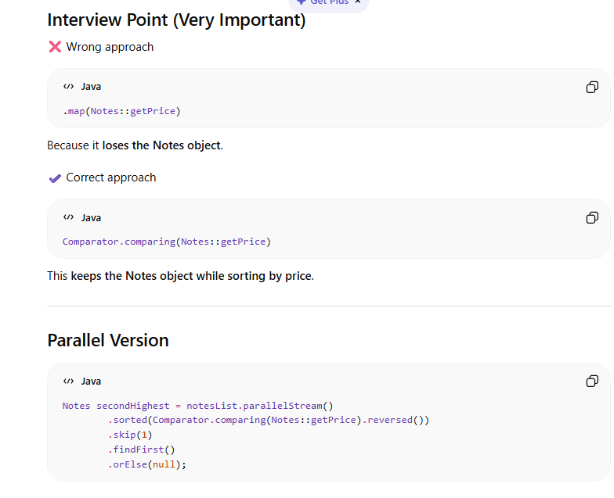
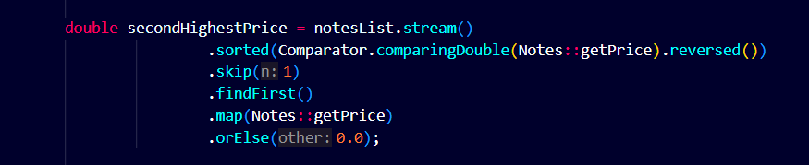
How this flow works ::
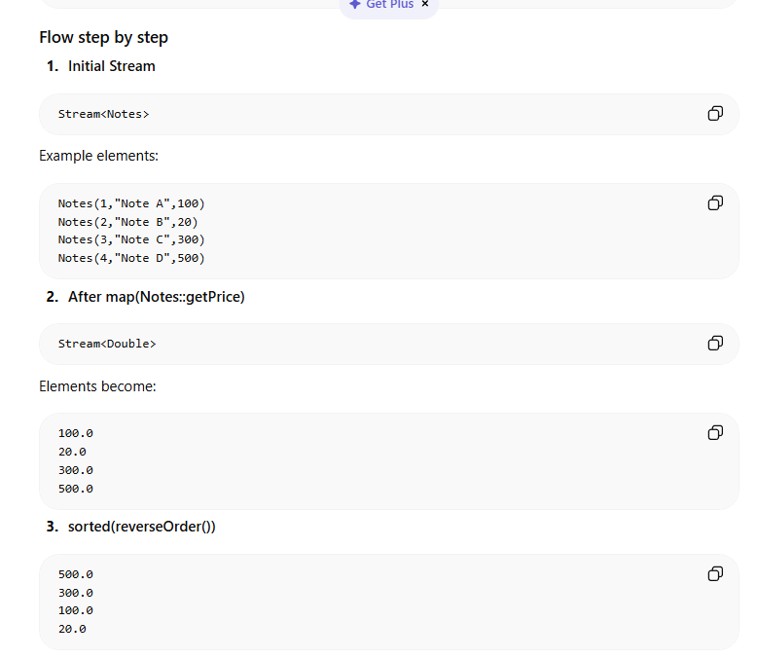
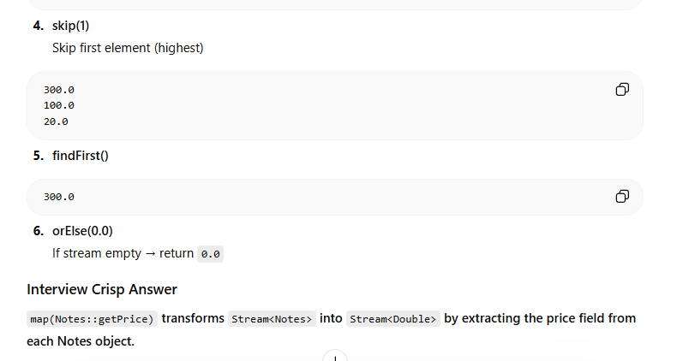
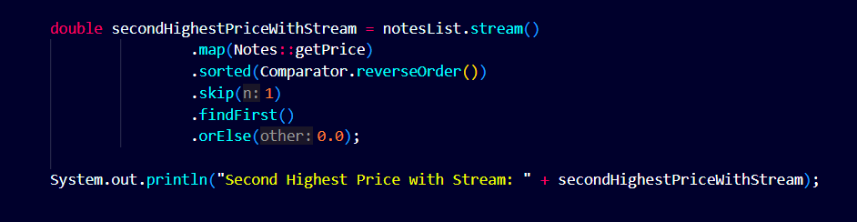
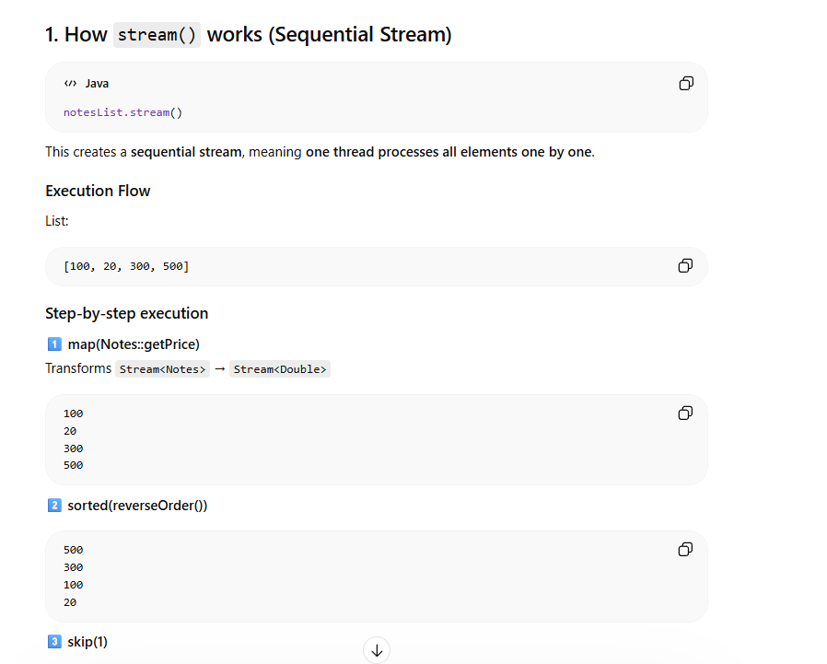
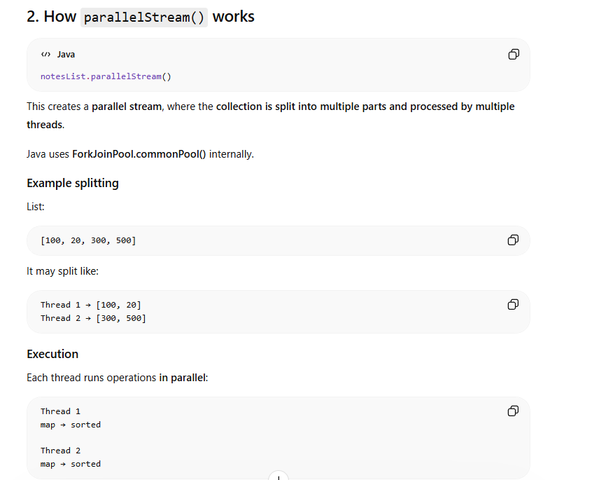
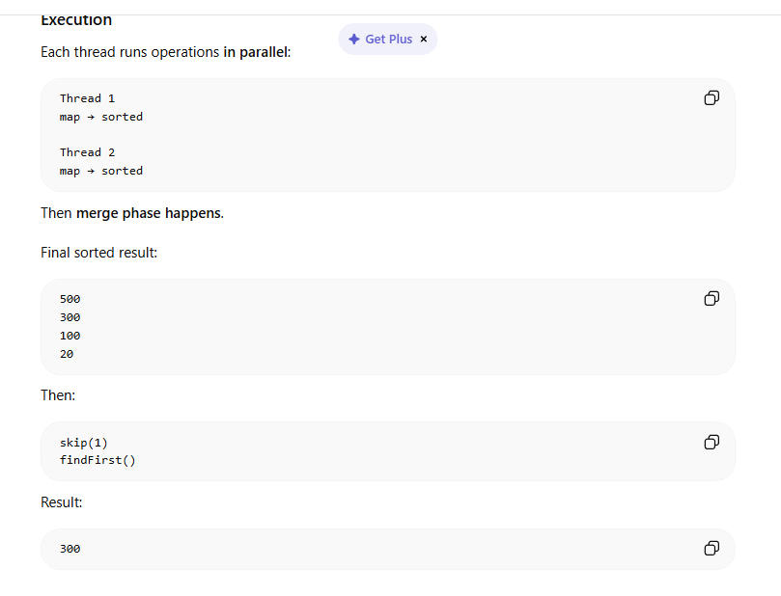
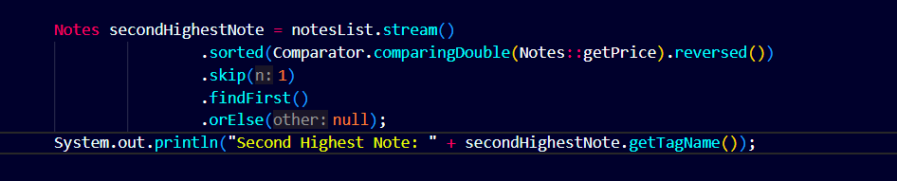
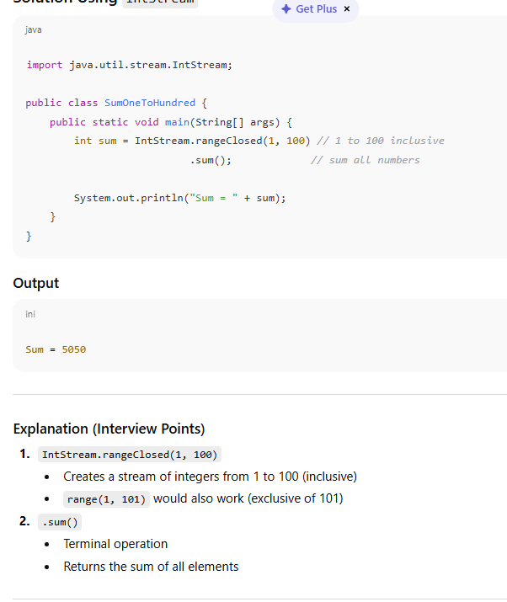
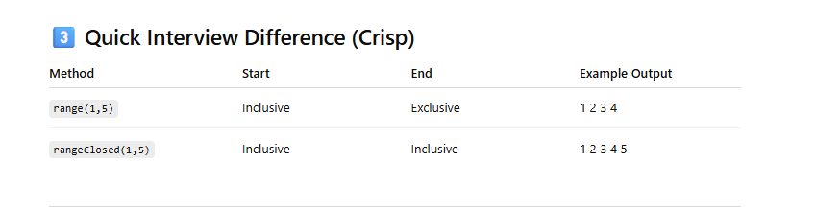
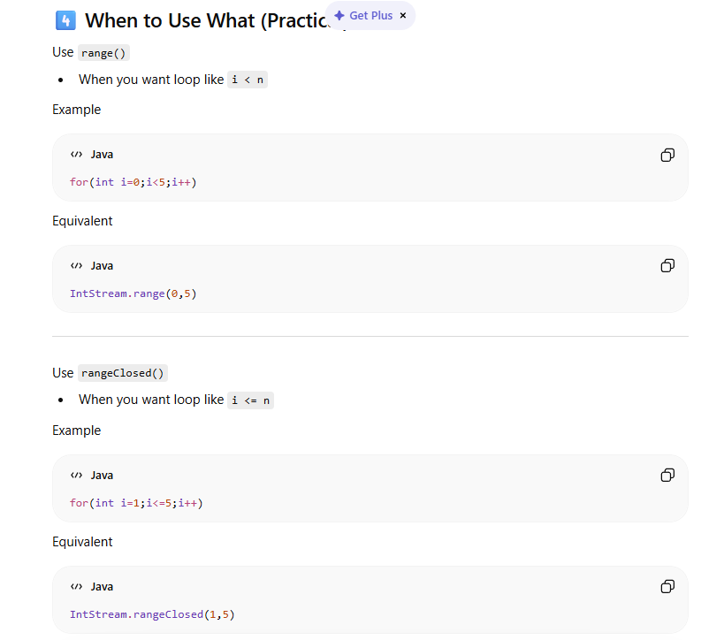
Reverse words order and reverse each word in String .
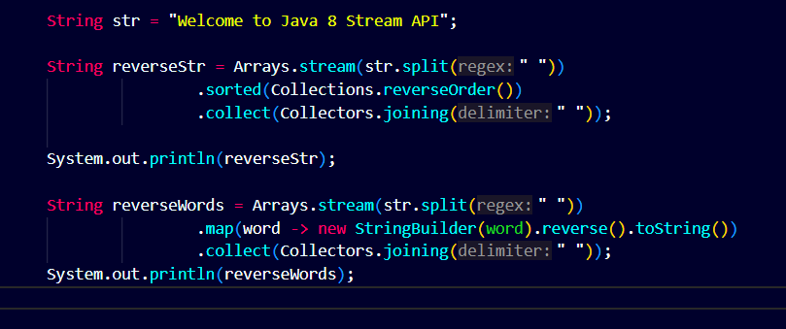
Output :
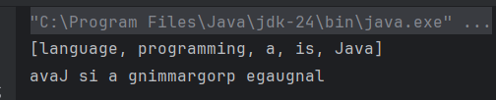
Map and FlatMap Coding Questions

